**DAILY ONLINE ACTIVITIES SUMMARY**

|  |  |  |  |  |  |  |  |  |
| --- | --- | --- | --- | --- | --- | --- | --- | --- |
| **Date:** | **8-7-2020** | | | | | **Name:** | **Prajna** | |
| **Sem & Sec** | **8th sem ‘B’** | | | | | **USN:** | **4AL16CS067** | |
| **Online Test Summary** | | | | | | | | |
| **Subject** | | **-** | | | | | | |
| **Max. Marks** | | **-** | | **Score** | | | **-** | |
| **Certification Course Summary** | | | | | | | | |
| **Course** | **Introduction to CSS** | | | | | | | |
| **Certificate Provider** | | | **Great learning** | | **Duration** | | | **5hrs** |
| **Coding Challenges** | | | | | | | | |
| **Problem Statement:**1**.** Write a c program to merge two arrays. | | | | | | | | |
| **Status: Completed** | | | | | | | | |
| **Uploaded the report in GitHub**  **GitHub link:** | | | | | **Yes**  **https://github.com/alvas-education-foundation/prajna_k** | | | |
| **If yes Repository name** | | | | | **prajna_k** | | | |
| **Uploaded the report in slack** | | | | | **yes** | | | |

Online Test Details: (Attach the snapshot and briefly write the report for the same)

Certification Course Details: (Attach the snapshot and briefly write the report for the same)

Coding Challenges Details: (Attach the snapshot and briefly write the report for the same)

2) certification course

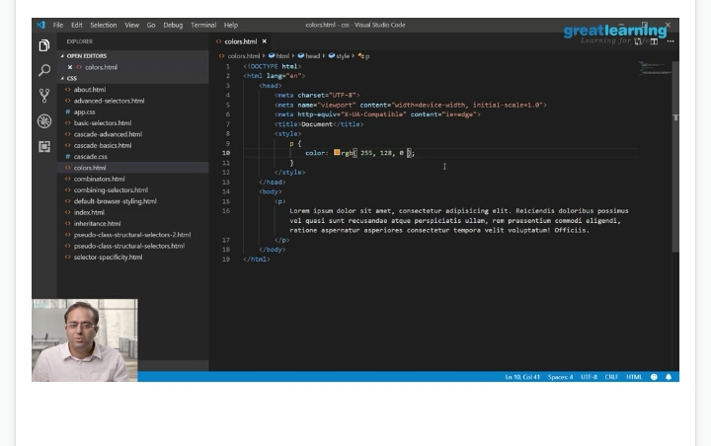

3) coding challenges

#include <stdio.h>

void main()

{

int arr1[100], arr2[100], arr3[200];

int s1, s2, s3;

int i, j, k;

printf("\n\nMerge two arrays of same size sorted in decending order.\n");

printf("------------------------------------------------------------\n");

printf("Input the number of elements to be stored in the first array :");

scanf("%d",&s1);

printf("Input %d elements in the array :\n",s1);

for(i=0;i<s1;i++)

{

printf("element - %d : ",i);

scanf("%d",&arr1[i]);

}

printf("Input the number of elements to be stored in the second array :");

scanf("%d",&s2);

printf("Input %d elements in the array :\n",s2);

for(i=0;i<s2;i++)

{

printf("element - %d : ",i);

scanf("%d",&arr2[i]);

}

/* size of merged array is size of first array and size of second array */

s3 = s1 + s2;

/*----------------- insert in the third array------------------------------------*/

for(i=0;i<s1; i++)

{

arr3[i] = arr1[i];

}

for(j=0;j<s2; j++)

{

arr3[i] = arr2[j];

i++;

}

/*----------------- sort the array in decending order ---------------------------*/

for(i=0;i<s3; i++)

{

for(k=0;k<s3-1;k++)

{

if(arr3[k]<=arr3[k+1])

{

j=arr3[k+1];

arr3[k+1]=arr3[k];

arr3[k]=j;

}

}

}

/*--------------- Prints the merged array ------------------------------------*/

printf("\nThe merged array in decending order is :\n");

for(i=0; i<s3; i++)

{

printf("%d ", arr3[i]);

}

printf("\n\n");

}

|  |
| --- |
|  |
|  |  |
|  |  |
|  |  |
|  |  |
|  |  |